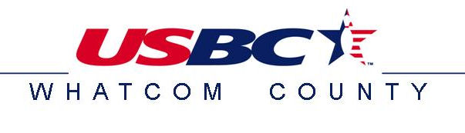
2018 Trios Tournament
With Blind Doubles Option

January 27th and 28th
Park Bowl
USBC Sanctioned

**ENTRIES CLOSE 30 MINUTES PRIOR TO THE START TIME OF EACH SQUAD**
You must bowl Trio’s to be eligible for Masters Champion consideration

SQUAD TIMES AVAILABLE

Saturday January 27th 11:00am 2:00pm

OR

Sunday January 28th 11:00am 2:00pm

Trios Team Fee $75  List Bowlers in order of desired line-up | USBC# | DATE & TIME | 2016-2017  Composite Average | Blind  Doubles  ($10 extra)
1
2
3
1
2
3

TEAM CAPTAIN: _______________________________________ Phone #_______________________

Drop entry form off at: Park Bowl, 20th Century Lanes or Mt. Baker Lanes or online at tournamentbowl.com

Fees breakdown per bowler: Fees breakdown for Blind Doubles per bowler:
Lineage fee: $11.00 Lineage fee: $ 0.00
Expense fee: $ 2.00 Expense fee: $ 2.00
Prize Fund: $12.00 Prize Fund: $ 8.00
Total: $25.00 Total: $10.00

FORMAT:
Format will be three games of regular 10-pin bowling on the same pair of lanes by a three-person team.

Blind Doubles teams will be created by random draw prior to the start of bowling.

ELIGIBILITY:
This tournament is USBC sanctioned. USBC cards or proof of card purchase for each team member must be presented prior to bowling. If you do not hold a USBC card, one can be purchased for Associate dues of $25. If you are not part of the Whatcom County USBC but have a USBC card elsewhere, you must pay a participation fee of $10.00.

MULTIPLE ENTRIES:
Event may be bowled more than once but at least one bowler must change on the team. Blind Doubles is limited to once per squad bowled.

ENTRIES:
Entries will close 30 minutes prior to the start of each squad. NO EXCEPTIONS!
Entry fee of $25.00 per bowler per event breaks down as follows: Lineage $11.00, Prize fund $12.00, Expenses $2.00. Entry fee of $10.00 per bowler for Blind Doubles breaks down as follows: Lineage $0.00, Prize fund $8.00, Expenses $2.00.

PLEASE SUBMIT PAYMENT WITH ENTRY.

AVERAGES:
Bowler must use their highest 2016-2017 COMPOSITE average for 21 games or more.
If no 2016-2017 average then: A current average based on 21 games or more by January 1, 2018 may be used. All others will enter using a 220 scratch average. (USBC Rule 319a(2) shall not apply).

CORRECT AVERAGE:
Average verification is required. Failure to report the correct average or make corrections prior to the end of the first game of any series shall result in disqualification if submitted average is LOWER than the correct average (USBC Rule 319a(3)). It is the responsibility of each bowler to verify the accuracy of their own average.

PRIZE FUND:
Prize ratio for the Trios portion will be 1 for every 5 entries.
Blind Doubles will pay the top three teams.
Prize money will be returned 100% with last place money at least equal to the prize fund fee.

HANDICAPS:
Team Handicap will be 90% of 660.

USBC RULES 319-c, 319-d, 319-e and 319-f are waived.

Tournament shall be governed by USBC rules not covered above.
Tournament House is limited to 10 lanes per event.
www.wcusbc.net

